Quick Start Guide Workflow #3 - Attending to Blue Leads
- Make sure it is assigned to someone
- Using your WORK board, click on the Contact Record and review the lead in the PERQ Tab
- If the lead as only done the New Customer Welcome, then your job is done.
  - Unless you have time left over for the day, then you can feel free to reach out – there is an email template called “New Customer Welcome Only” that you can use. If you do not have this template, ask your PERQ CSM to get it loaded for you.

Example of New Customer Welcome Only:

If they have done more than the New Customer Welcome – and you feel you have enough info AND Time, plan to reach out.

Example of another Blue Lead with More information:
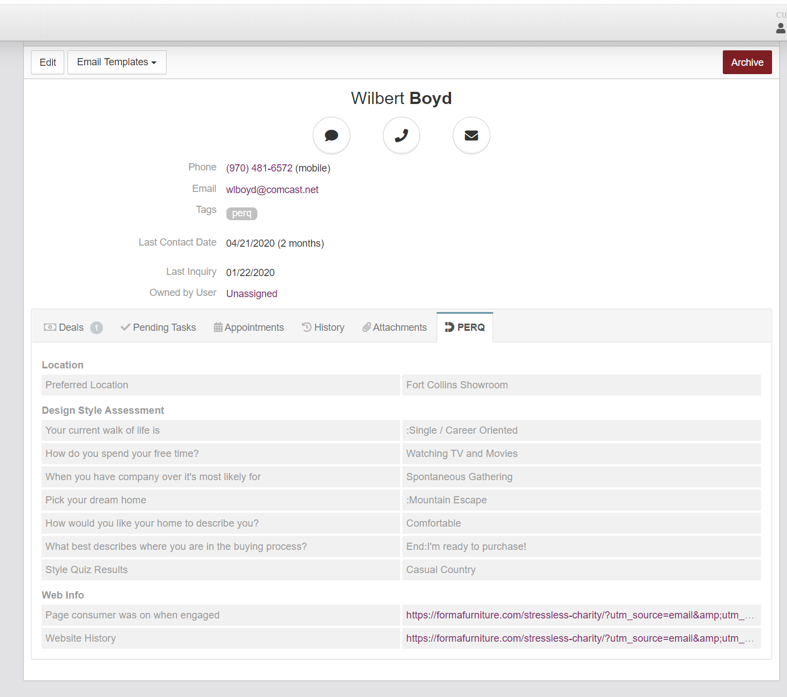

PRO TIP: If you plan to reach out, try 1 to 2 times over 3 to 5-days.

- It is OK if you never reach out to the BLUE Leads because ALL LEADS (regardless of color) will get an automated email message campaign from the store.

NOTE: All leads will Auto-Close after 30 days of inactivity. This means, you have not TOUCHED the contact record in any way, the customer has not engaged, etc, within 30 days. Once the contact closes, they will be removed from the auto-emails, as well. This time can be adjusted to 45-60-or-90-days if needed. Ask your PERQ CSM for guidance.

